To Cowi,

The Drone Engineering team have been discussing different ideas and solutions that could improve and smoothen out the bridge inspection procedure.

At SDU we are being provided with a Drone, photos of it can be seen below. The drone has a maximum height of 66cm (to the tip of the antenna) and maximum width of 84cm (from propeller tip to propeller tip).

|  |  |
| --- | --- |
| Front view | Top view |

**What we intend to achieve**

* A **collision avoidance system** should be implemented to avoid collision on the drone. The pilot should be able to apply full throttle heading towards a wall and the drone should detect there is a wall and stop and hover instead of flying into it. For this solution we will probably need to add sensors to detect the surroundings. Would this be possible to integrate it into your current DJI framework?
* A **smart path planning** meaning the drone would detect the shape of the bridge and follow it in a logical way. A picture to explain it can be seen just below. The yellow and blue circle would be the drone at different positions and doing different path plannings. The yellow circle shows how the drone would behave by flying around the column of the bridge. The blue circle shows how the drone would behave when following the shape of the arc.

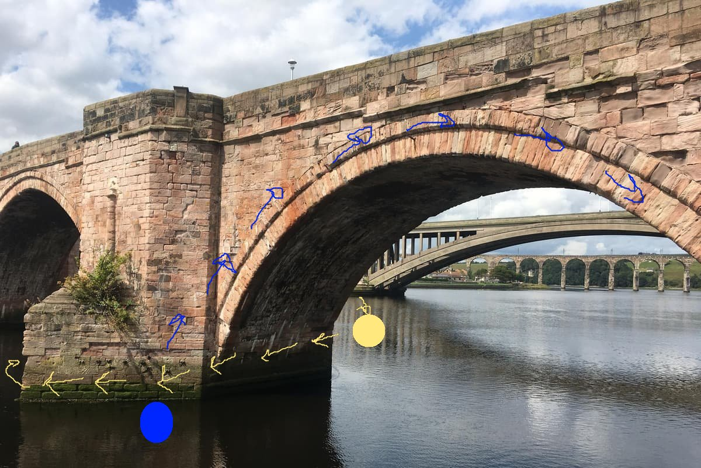

**What we would like to know from you:**

* Could we get a detailed explanation of how the bridge inspection is done?
* How long does the drone usually fly? Does it run out of battery before you can finish the inspection?
* Could you update us on problems you encountered during the procedure?
* How are the videos and images being stored? Have you tried streaming them in real time?
* Would we be allowed to have video data to work with and simulate?
* What DJI models are you using? If you are using other brands which, are they?
* Have you encountered any connection problems with the drone? If so, when, and why do they usually happen? Do you have any data regarding this?

Many thanks in advance.